**Create Supplier - CI_VNDR_ID_EXCEL**

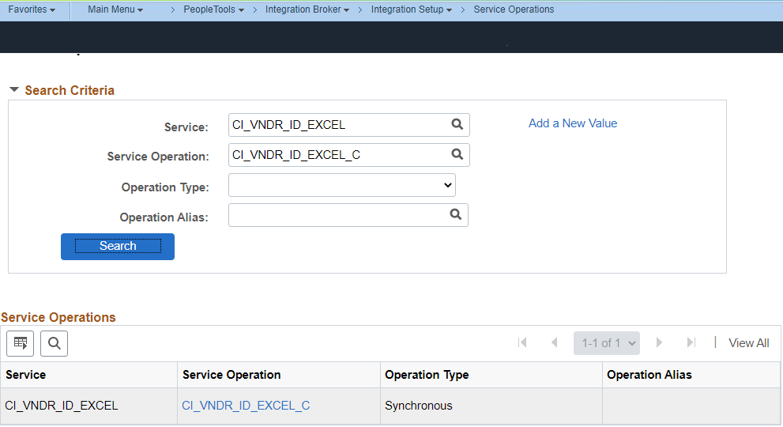

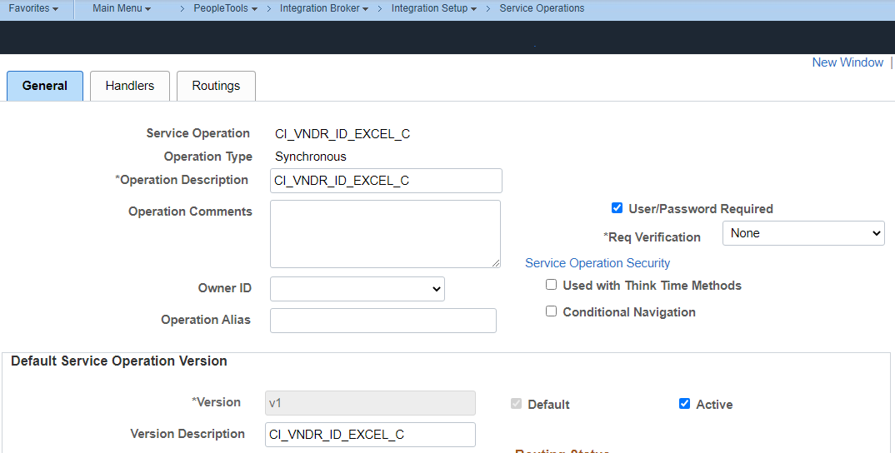

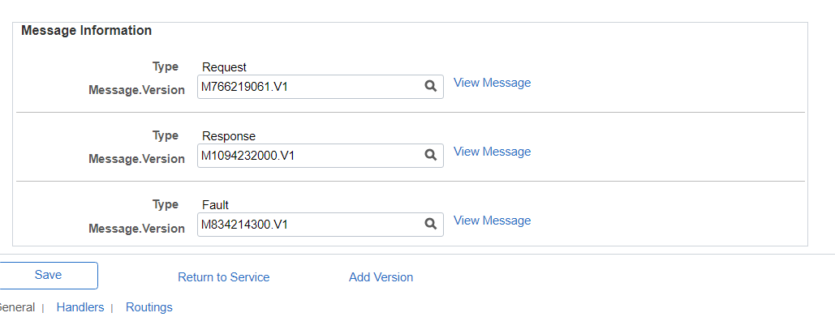

Copy these 3 files in one local folder. wsdl file also copy and place in the same folder.

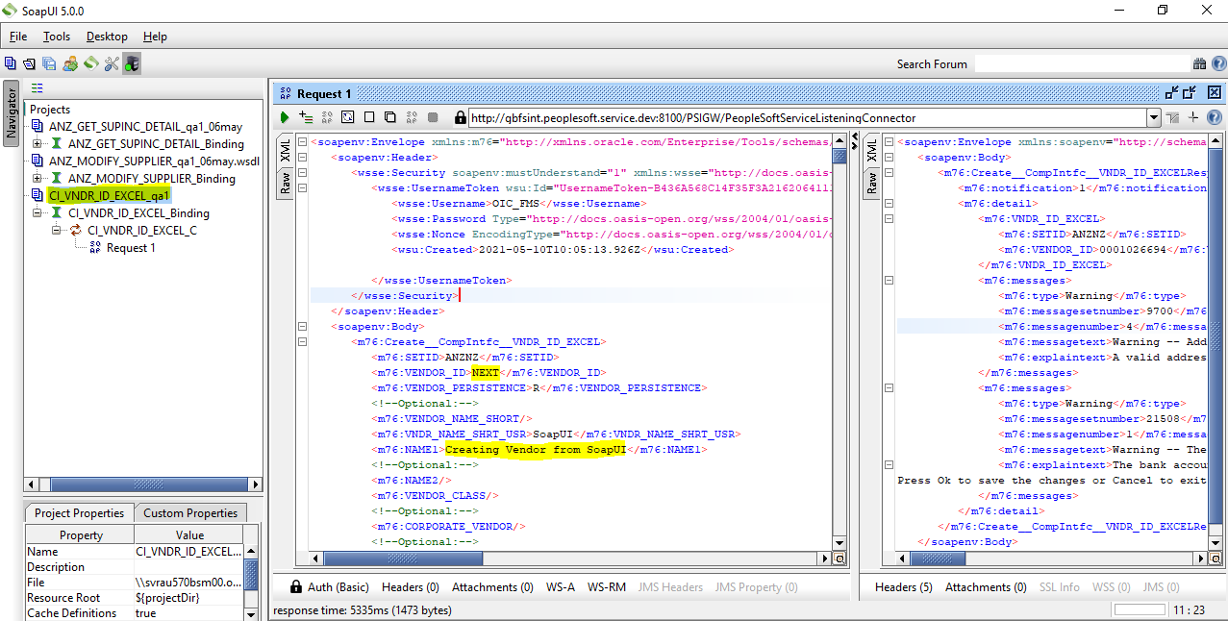

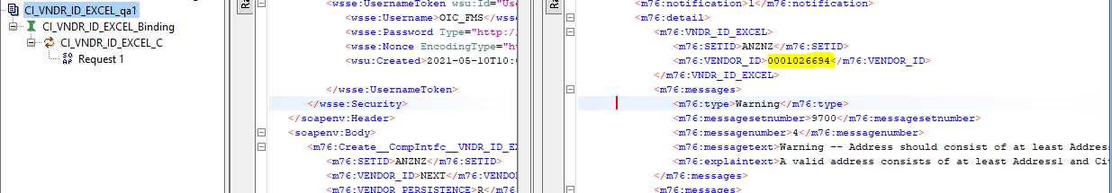

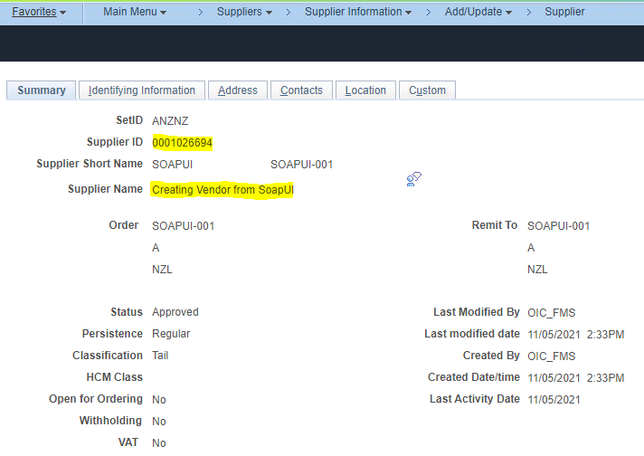

**Modify Supplier - ANZ_MODIFY_SUPPLIER**

Load the modify supplier wsdl file to SoapUI and modify the data for a particular supplier.

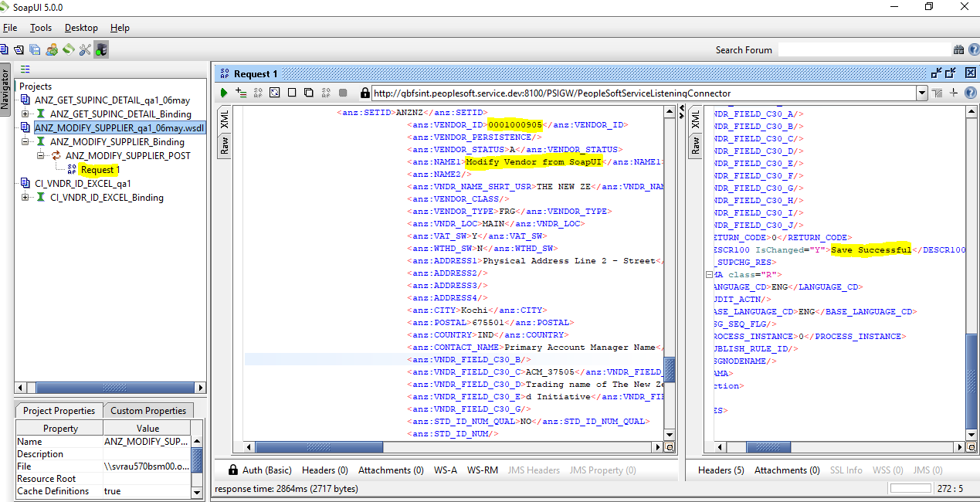  
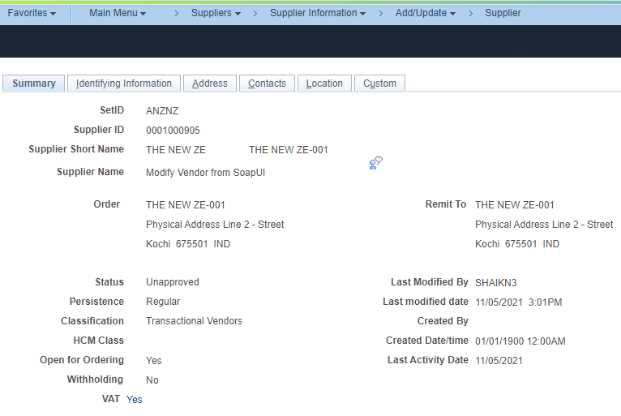

**Supplier Incremental -ANZ_GET_SUPINC_DETAIL**

Load the supplier incremental wsdl file to SoapUI and validate the supplier details by providing from date and to date range.

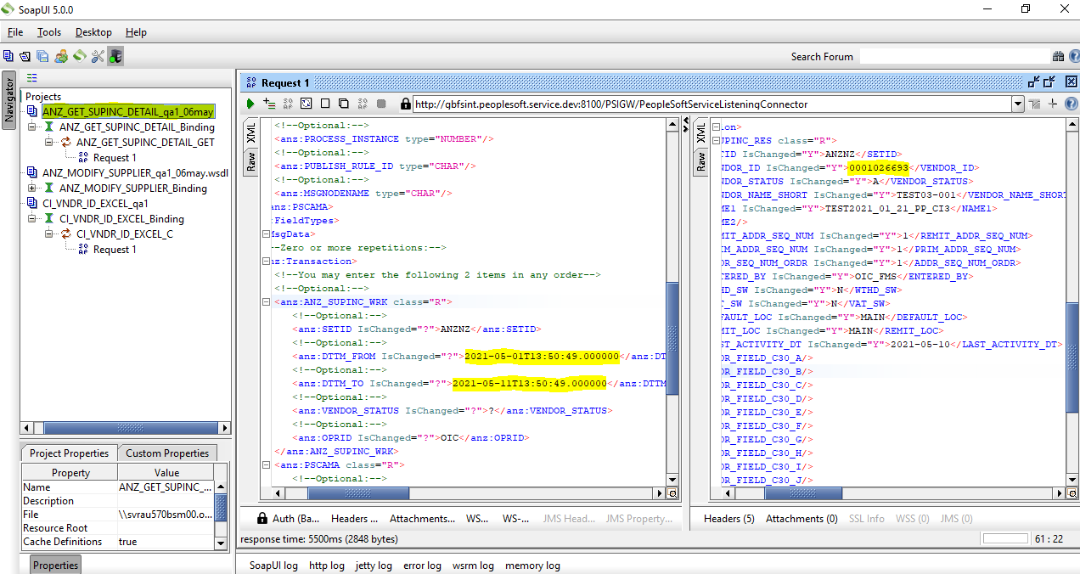

**Get Supplier - ANZ_GET_SUP_DETAILS**

Load the get supplier wsdl file to SoapUI and validate the supplier details by providing ACM_ID value.

